**EXPERIMENT 2**

**AIM:** Study of different type of Network Devices.

**Different types of network devices**

**HUB:**

Hub is work on physical layer. Network using a star topology require central point for the device to connect. This device was called a concentrator since it consolidated the cable runs from all network devices.

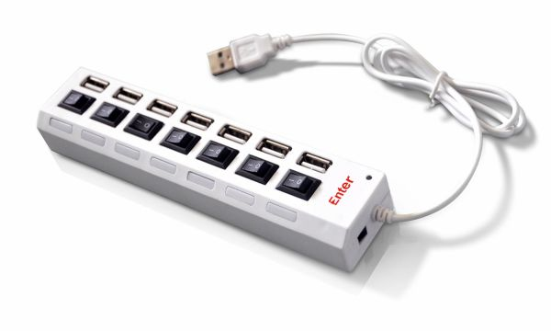

A hub is used in a wired network to connect Ethernet cables from a number of devices together. The hub allows each device to talk to the others. Hubs aren’t used in networks with only wireless connections, since network devices such as routers and adapters communicate directly with one another. Hubs are such simple devices – they require no configuration, and have no manuals – that their function is now included in other devices such as routers and modems.

**MODEM**

A modem links your home network to the Internet through your Internet Service Provider (ISP). The high speed types of data outside of your home aren’t suitable or your direct use, so modems convert the data into digital Ethernet, which all the network equipment in your home can use.

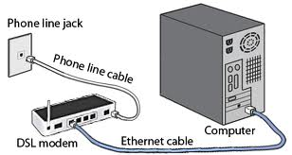

A modem is a device that makes it possible for computers to communicate over telephone lines. The world modem comes from Modulate and Demodulate. Because standard telephone lines use analog signals, and computers digital signals, a sending modem must modulate its digital signals into analog signals. The computers modem on the receiving end must then demodulate the analog signals into digitals signals.

Modems can be external, connected to the computers serial port by an RS-232 cable or internal in one of the computers expansion slots. Modems connect to the phone line using standard telephone RJ-11 connectors.

**SWITCH**

A switch or network switch is a small hardware device that joins multiple computers together within one Local Area Network (LAN). Technically, network switches operate at layer two (Data Link Layer) of the OSI Model.

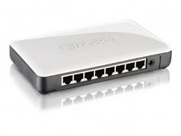

Network switches appear nearly identical to network hubs, but a switch generally contains more intelligence (and a slightly higher price tag) than a hub. Unlike hubs, network switches are capable of inspecting data packets as they are received, determining the source and destination device of each packet, and forwarding them appropriately. By delivering messages only to the connected device intended, a network switch conserves network bandwidth and offers generally better performance than a hub.

**ROUTER**

Routers work on the network layer so they can filter data based on IP addresses. They have route tables to store network addresses and forward packets to the right port.

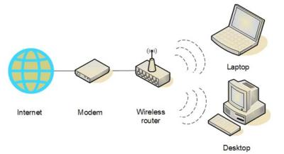

A router is a communications device that connects multiple computers or other routers together and transmits data to its correct destination on the network. A router can be used on any size of network. On the largest scale, routers along the Internet backbone forward data packets to their destination using the fastest available path. For smaller business and home networks, a router allows multiple computers to share a single high-speed Internet connection such as through a cable modem or DSL modem. These routers connect from 2 to 250 computers.

**BRIDGE**

Bridge is work on the data link layer so in principle they are capable to do what switches do like data filtering and separating the collision domain, but they are less advanced. They are known to be used to extend distance capabilities of networks.

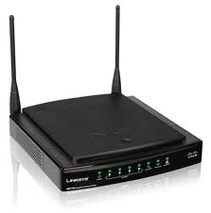

A bridge reads the outermost section of data on the data packet, to tell where the message is going. It reduces the traffic on other network segments, since it does not send all packets. Bridges can be programmed to reject packets from particular networks. Bridging occurs at the data link layer of the OSI model, which means the bridge cannot read IP address, but only the outermost hardware address of the packet. In our case the bridge can read the Ethernet data which gives the hardware address of the destination address, not the IP address. Bridges forward all broadcast messages. Only a special bridge called a translation bridge will allow two networks of different architectures to be connected. Bridges do not normally allow connection of networks with different architectures. The hardware address is also called the MAC (media access control) address.

**GATEWAY**

A network gateway is an internetworking system capable of joining together two networks that use different base protocols. A network gateway can be implemented completely in software, completely in hardware, or as a combination of both. Depending on the types of protocols they support, network gateways can operate at any level of the [OSI model](http://compnetworking.about.com/cs/designosimodel/g/bldef_osi.htm).

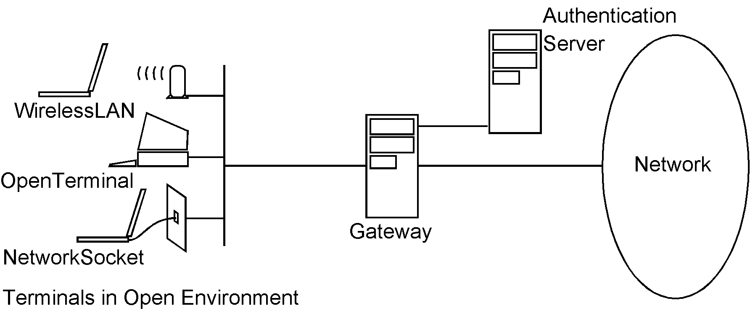

**Function**

A network gateway joins two networks together through a combination of hardware and software.

**Advantages**

Direct connections between internal and external hosts are disallowed. User-level authentication is supported. The application commands are analyzed inside the payload portion of the data packets

**Disadvantages**

Slower than packet filters  
needs the internal client to know about them.  
Every possible type of connection cannot be supported

**NICs(Network Interface Card)**

Network Interface Card, or NIC is a hardware card installed in a computer so it can communicate on a network. The network adapter provides one or more ports for the network cable to connect to, and it transmits and receivers data onto network cable.

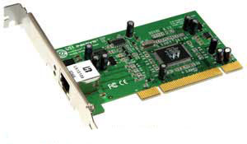

Every networked computer must also have a network adapter driver, which controls the network adapter. Each network adapter driver is configured to run with a certain type of network adapter.

**Function of NIC:**

1. ➢ Data Transfer
2. ➢ Data Buffering
3. ➢ Frame Construction
4. ➢ Media Access Control
5. ➢ Parallel/Serial Conversion
6. ➢ Data Encoding/Decoding
7. ➢ Data Transmission/Reception